**Smart Device & Mobile Emerging Technologies Assignment**

*Mei Chiao Lin, Oct 19th , 2019*

1. For the Smartphone project, setup the project suitable to your smartphone and conduct the experiment on both Android and iPhone smartphones. Describe the smartphone types and the specs of the CPU, SoC, number of cores, memory types & sizes of each smartphone.

(a) [Android Smartphone_HTC U12+]

Device Type: Phablet

Specs of the CPU: 4x Qualcomm Kyro 385 Silver@1766MHz, Gold@2803MHz

SoC Model: Qualcomm Snapdragon 845

Number of Cores: 8

Memory types: RAM 6GB LPDDR4X

Total Memory: 5680MB

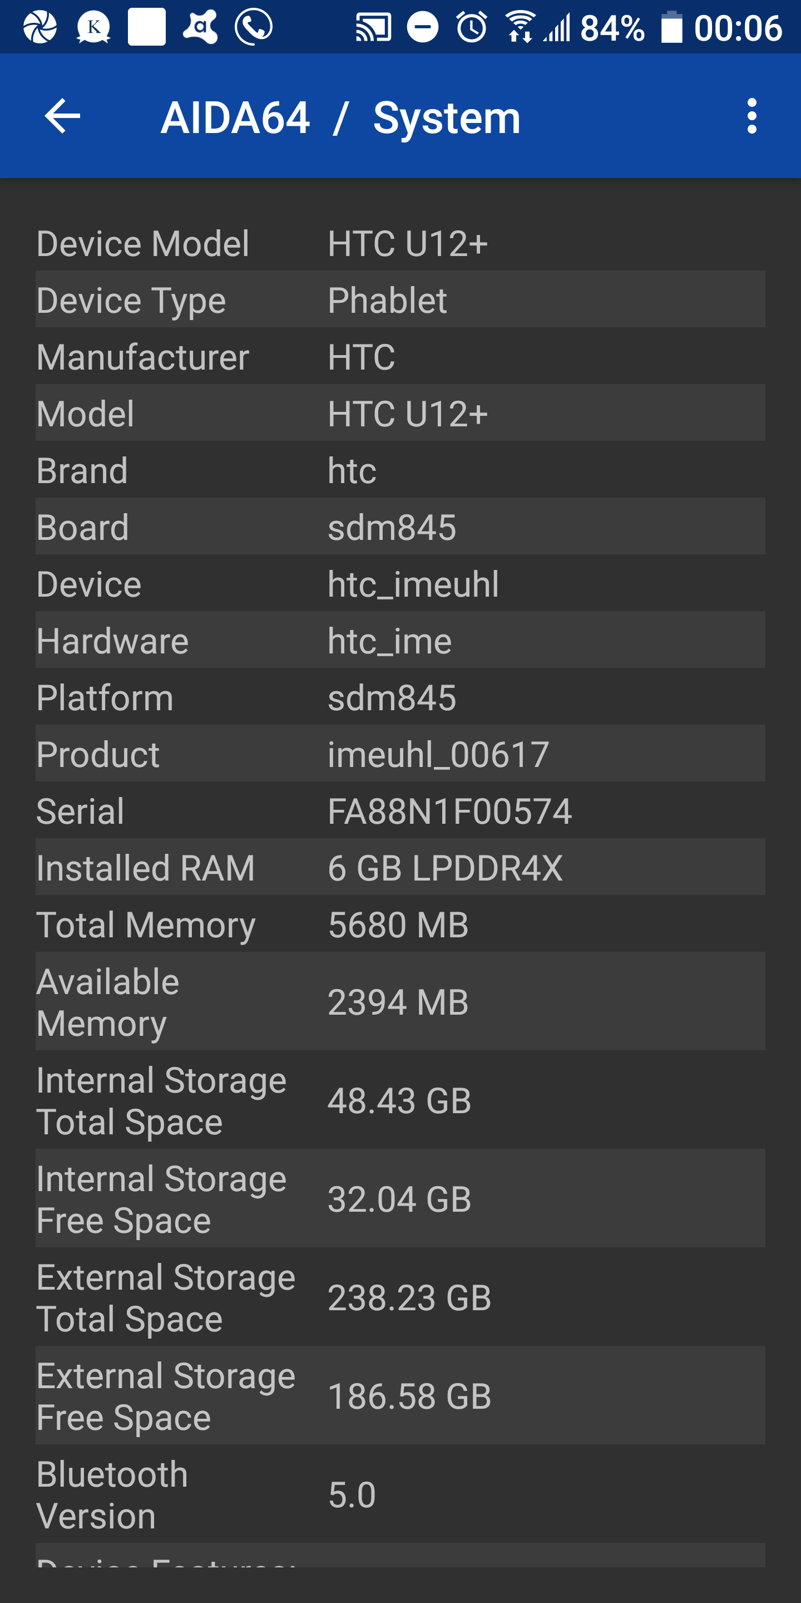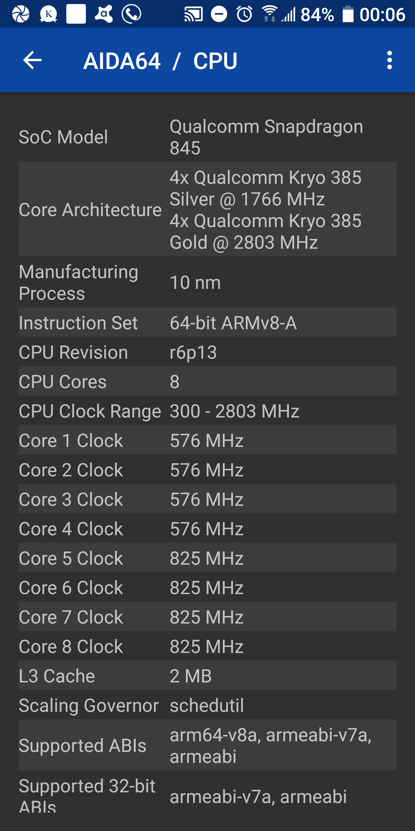

(b) [iPhone 6]

CPU Type: Apple A8

Specs of the CPU: Speed 1400MHz, Manufacturer TSMC, Instruction Set 64-bit ARMv8-A, Microarchitecture Cyclone 2, Technology 20nm.

Number of Cores: 2

Memory: 64GB Storage, 1987MB RAM

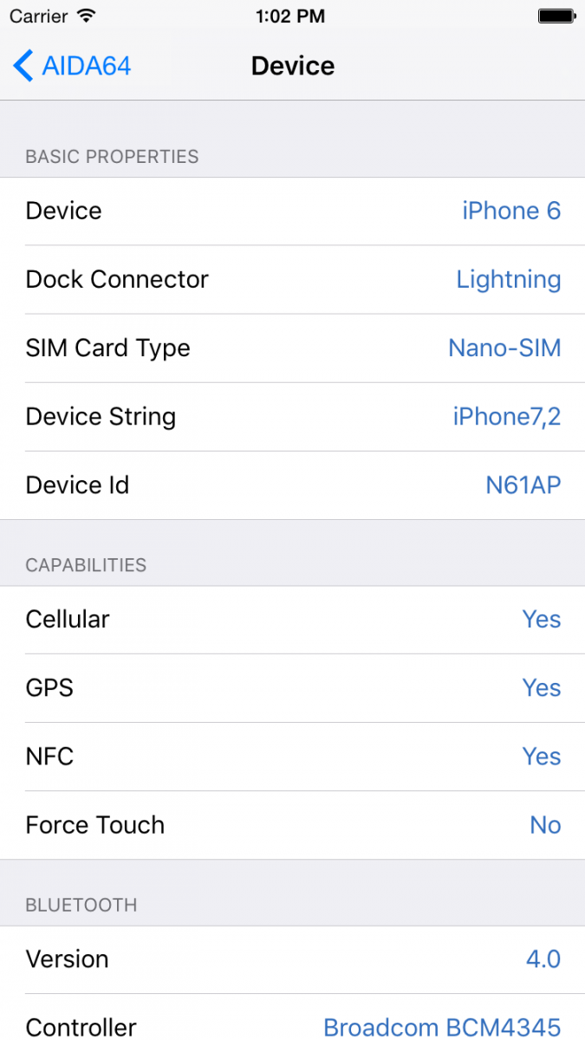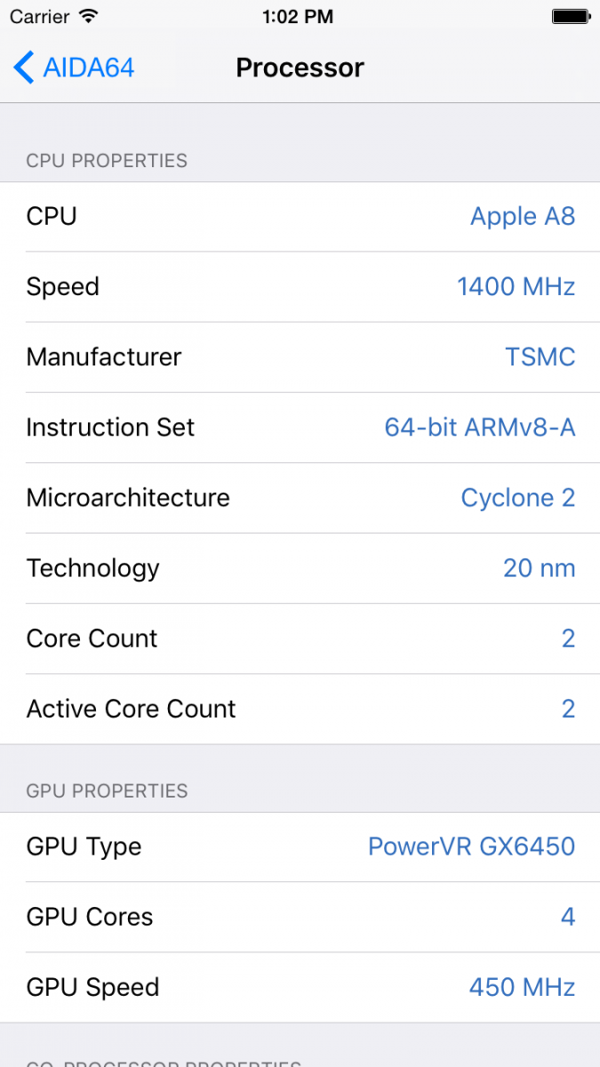

1. For the Mobile Network project, setup the project suitable to your smartphone and conduct the experiments. Describe the location of where you experienced the largest number of Neighbor Base Stations, and how many were there. In addition, describe the PCI, RSSI, RSRP, RSRQ, RSSNR, ASU, and CQI values measured.

Only one neighbor base stations,

PCI: 256

RSRP: -83,

RSRQ: -11

RSSNR: 300

ASU: 57

CQI: N/A

